Project Documentation

D202 – Agile Team Project

Scrum Team Name: **The Four Horsemen**

Scrum Team Members: **Dale Lochrie, Matt Paul, Neil Asplin, Stalin Fernandes**

TOC

# Project Overview

**Start Date:** 11/08/16

**Release/End Date:** 20/10/16

**Application Use:** To support degree students in planning their study options

**Scrum Team Capacity:** 4

**Project Allocated Hours:** 24 Hours (12 hours of sprints)

**Number of Sprints:** 4

**Sprint Duration:** 3 Hours

# Group Project Setup and Sprint Planning (Sprint One)

|  |  |  |
| --- | --- | --- |
| Date | Time: | Duration: |
| 11/08/2016 | 9:00am | 3 Hours |

## Sprint One Roles:

**Product Owner:** Aaron Steele

**Scrum Master:** Neil Asplin

**Scrum Members:** Dale Lochrie, Matt Paul, Neil Asplin, Stalin Fernandes

## Stated Requirements

* Be designed for use within the lab network, ideally single sign on will be supported so that the user is automatically logged in
* Use a database for backend data storage
* Store all of the courses available in the degree (code, name, description, semester offered, pre-requisite course code, compulsory (Y/N))
* Categorise the courses available by topic area
* Allow the user to enter the courses they have passed (academic history)
* Based on their history, display to the user the courses they are eligible to take
  + Ideally this will be able to be filtered by topic area (e.g. infrastructure courses)
* Allow the user to select a plan of study (select courses for following semesters)
  + You will support the planning of up to four semesters (this will allow a year one student to plan study for the remainder of their degree)
* Allow the user to save the plan of study in a format which is able to be emailed or printed.

## Development Environment

* Microsoft Visual Studio
  + C#
  + Windows Forms
* Microsoft Access

## Version Control

* Git Portable
* GitHub
  + Team Project Repository Created
  + Team Members Invited

We briefly tested Git and became familiar with basic commands.

|  |  |  |
| --- | --- | --- |
| Priority# | User Stories | Story Points |
| #01 | As a Student, I would like to login to the application manually | 13 |
| #02 | As a lecturer, I would like all the courses stored with codes and value names. | 5 |
| #03 | As a lecturer, I would like to be able to make changes to paper details. | 30 |
| #04 | As a Student, I would like to enter the courses that I have passed and save my academic history. | 8 |
| #05 | As a Student, I would like to see available future papers, filtered by topic area, based on papers I have already completed. | 8 |
| #06 | As a Student, I would like to be able to select a plan of study for up to four semesters. | 5 |
| #07 | As a student, I would like to be able to save a plan of study in a format that can be emailed or printed. | 8 |
| #08 | As a Student, I would like the application to manage my details. | 8 |
| #09 | As a student, I would like to categorise the courses into topic areas. | 5 |
| #10 | As a Student, I would like to automatically log in, so that I don’t have to log in multiple times. | 13 |
|  | **Total Story Points** | **103** |

## Sprint One User Stories

## Tasks for Sprint One

|  |  |
| --- | --- |
| User Story #01 Tasks | Points |
| Create Sample Database | 3 |
| Create Windows Form C# Application | 3 |
| Create Login Forms | 7 |

|  |  |
| --- | --- |
| User Story #02 Tasks | Points |
| Create lecturer table in database | 1 |
| Connect Database to C# project | 2 |
|  |  |

# Sprint 1

**Appointment Time for Sprint Review and Sprint Retrospective Meeting:** 11:00am with Project Owner

## Daily Scrum Meeting

|  |  |  |  |
| --- | --- | --- | --- |
|  | What did you do last time? | What will you do today? | Are there any impediments in your way? |
| Neil |  |  |  |
| Matt |  |  |  |
| Stalin |  |  |  |
| Dale |  |  |  |
| Did Aaron Attend? | YES/NO |

## Retrospective Meeting:

|  |  |  |  |
| --- | --- | --- | --- |
|  | Task status?  (Start doing, stop doing, continue doing) | In hindsight could you have done anything better? | Other Information |
| Neil |  |  |  |
| Matt |  |  |  |
| Stalin |  |  |  |
| Dale |  |  |  |
| Did Aaron Attend? | YES/NO |

## Sketch User Interface

## Entity Relationship Diagram

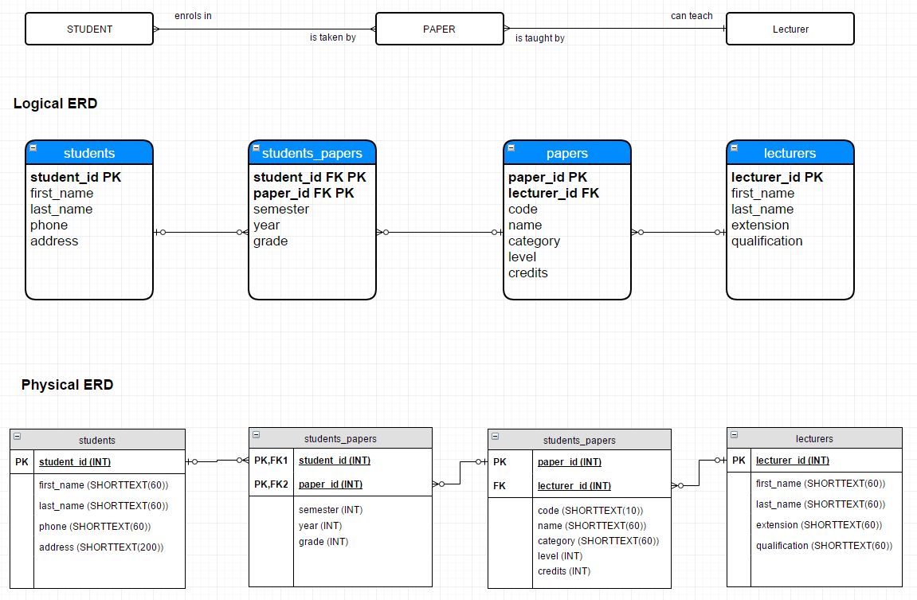

## Burndown Chart